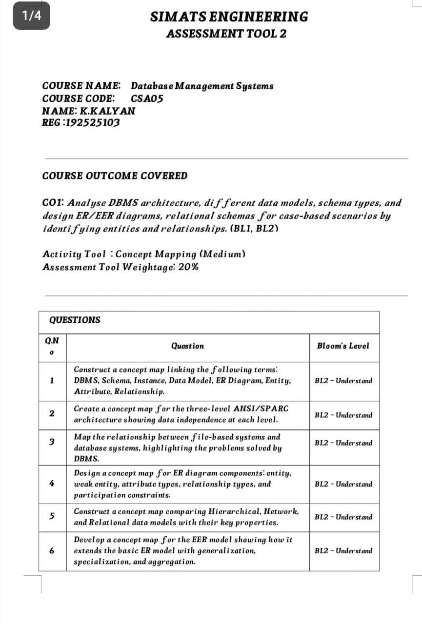

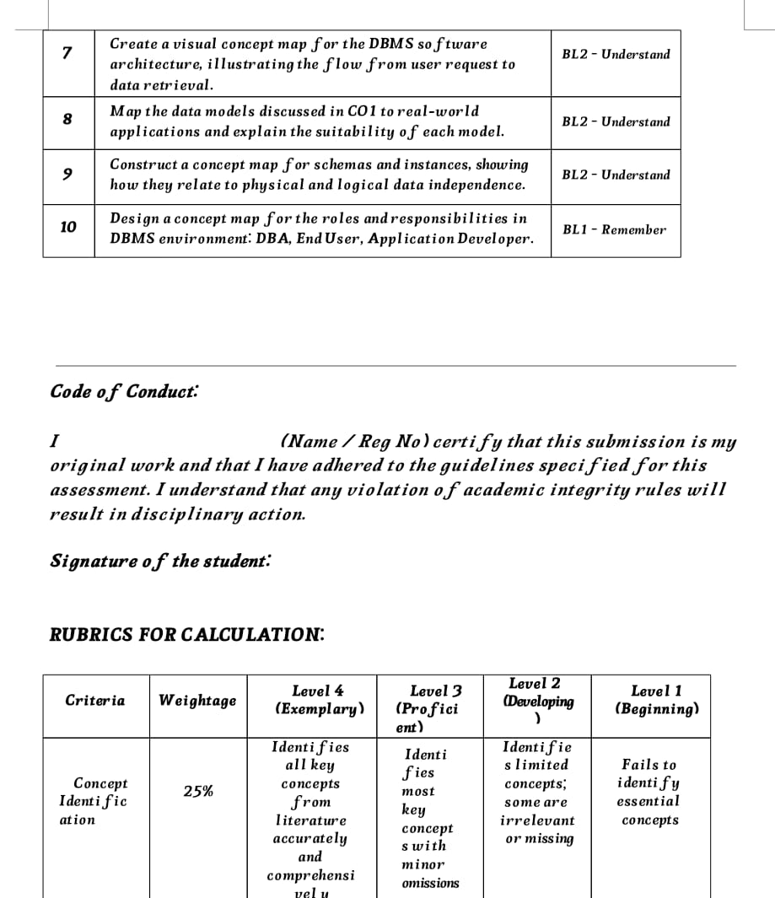

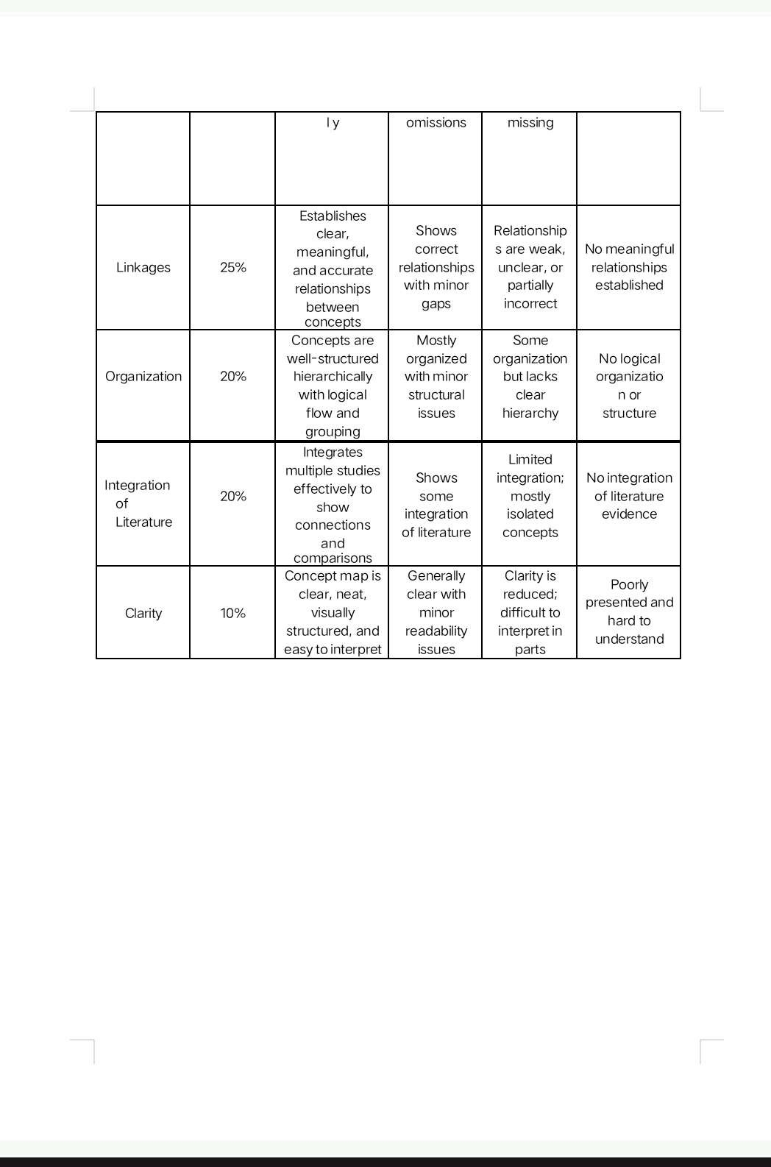

- Costruct a concept map linking the following terms: DBMS, Schema, Instance, Data Model, ER Diagram, Entity, Attribute, Relationship.

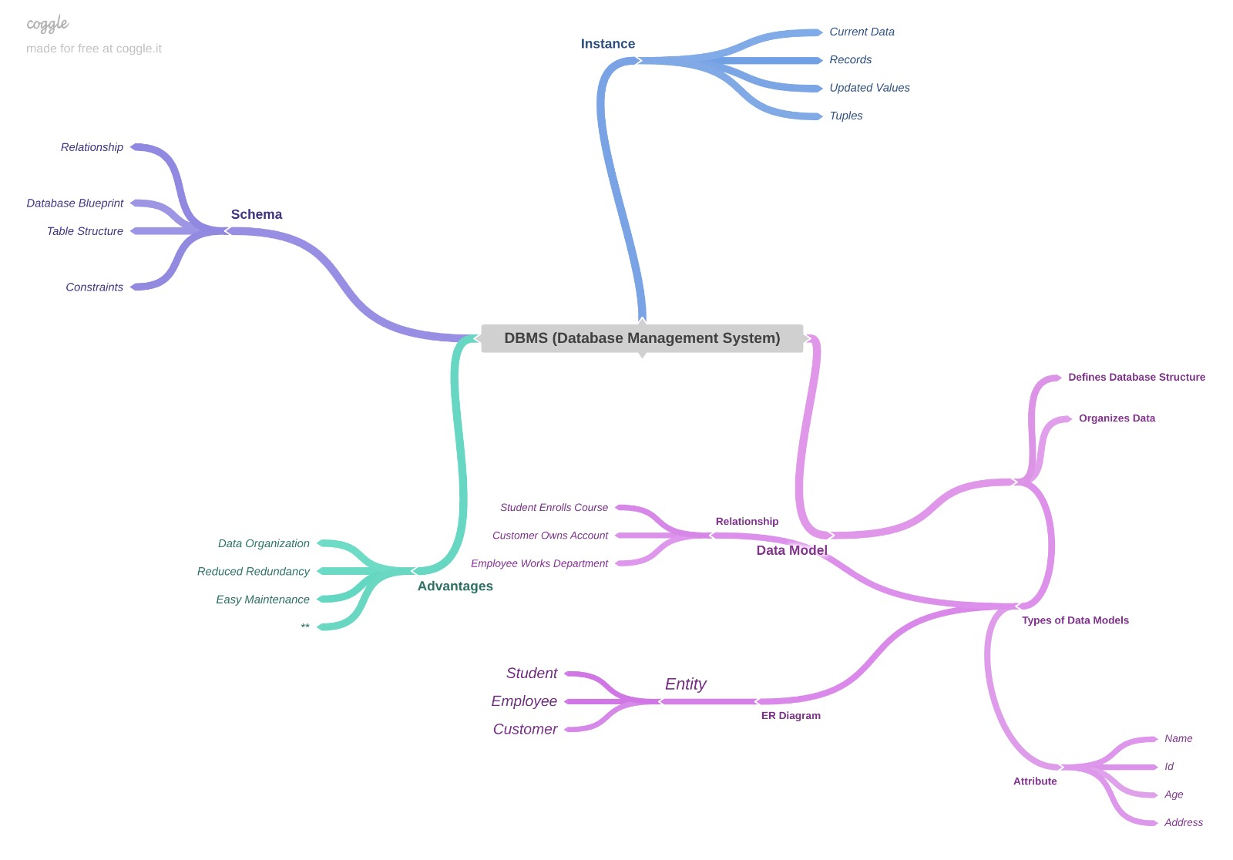

- Create a concept map for the three-level ANSI/SPARC architecture showing data independence at each level.

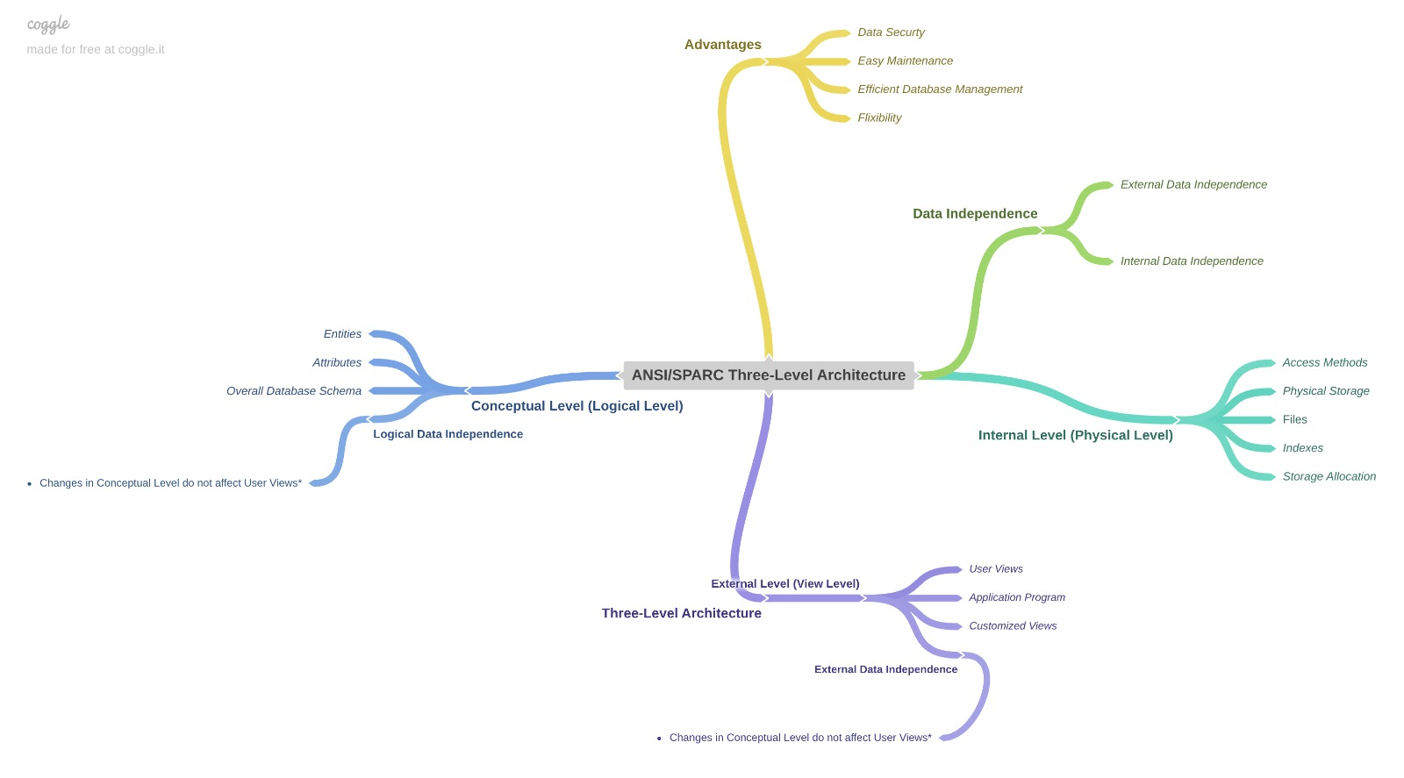

3 Design a concept map for ER diagram components: entity, weak entity, attribute types, relationship types, and participation constraints.

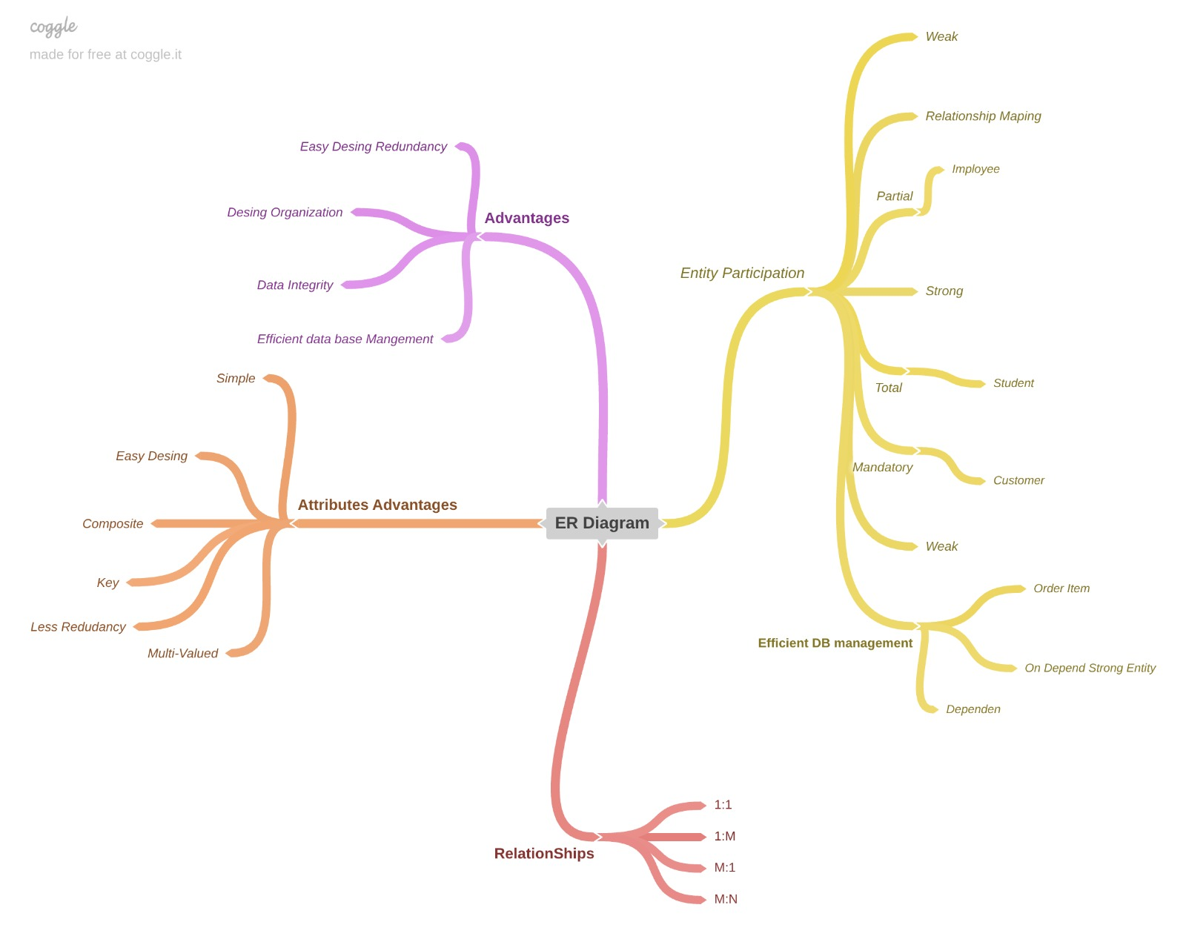

4 construct a concept map comparing Hierarchical, Network, and Relational data models with their key properties.

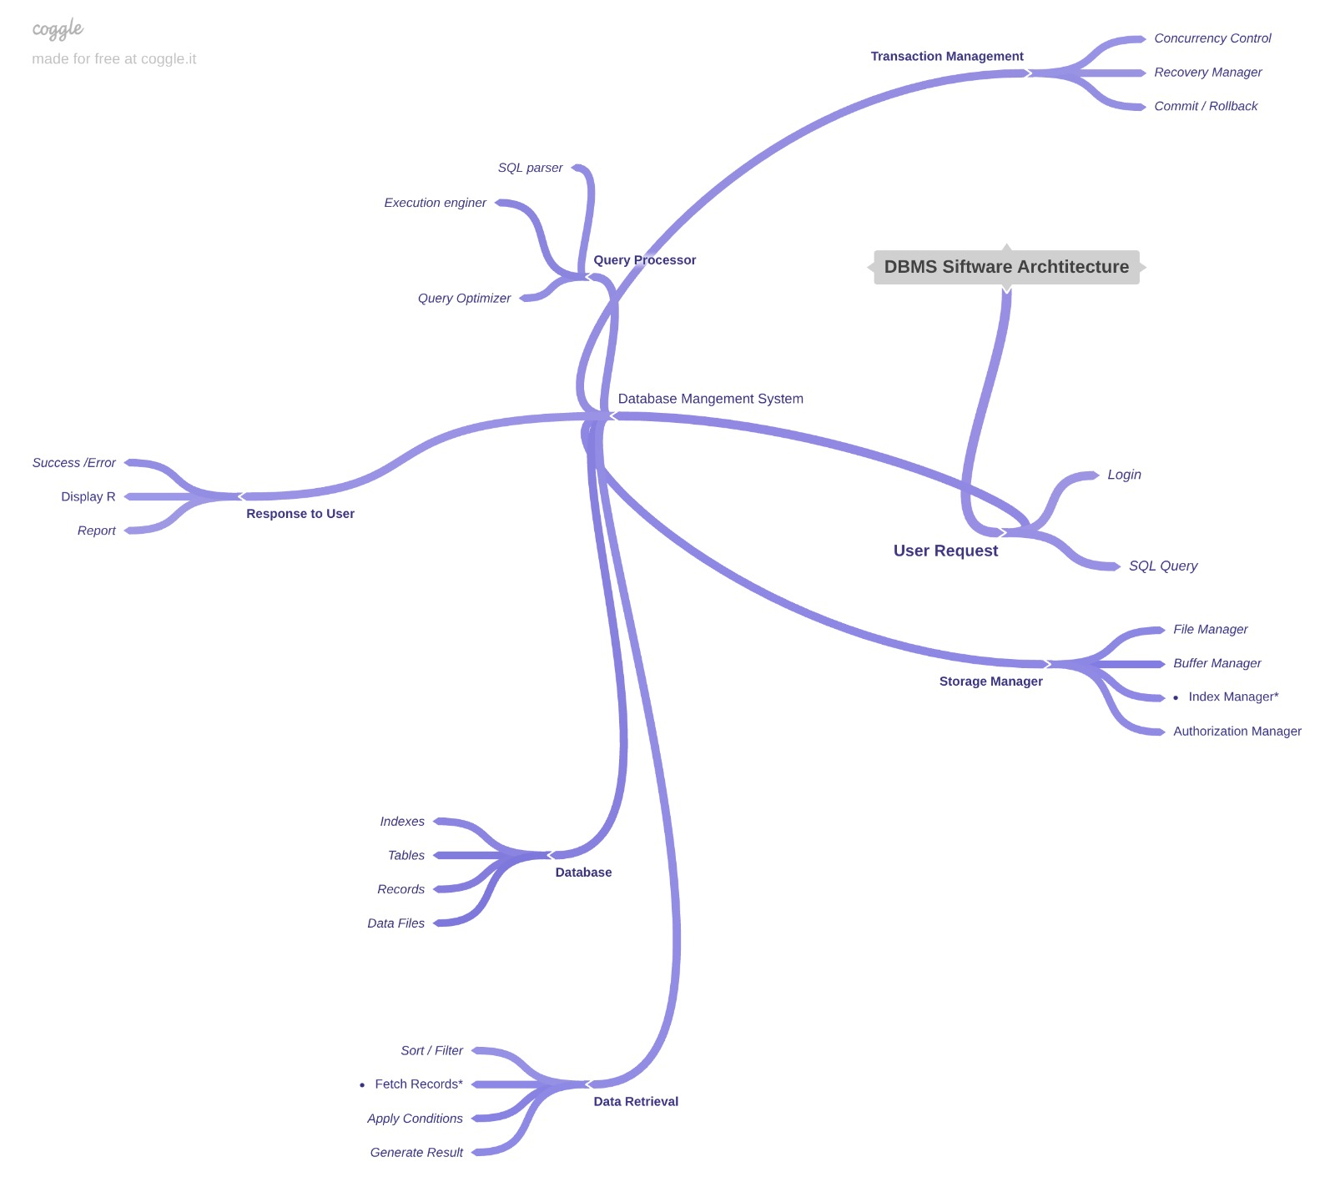

5.construct a concept map comparing Hierarchical, Network, and Relational data models with their key properties.
